
Name: Janushiya P A
Reg No: 1924260368
Course Code: CSA0224
Course Name: C Programming

TASK 7 – CONTROL TYPE CONVERSION AND PRECISION
Bloom’s Level: K4 – Analyse

1. Aim
To understand type conversion, integer division, explicit casting, and rounding errors in C, and to ensure accurate electricity bill calculations.

2. Algorithm
- Start.
- Declare variables of different data types.
- Evaluate expressions involving implicit conversion, integer division, and explicit casting.
- Display the results.
- Calculate money using integer paise and apply a consistent rounding rule.
- Compare integer and floating-point calculations.
- Stop.

3. C Program

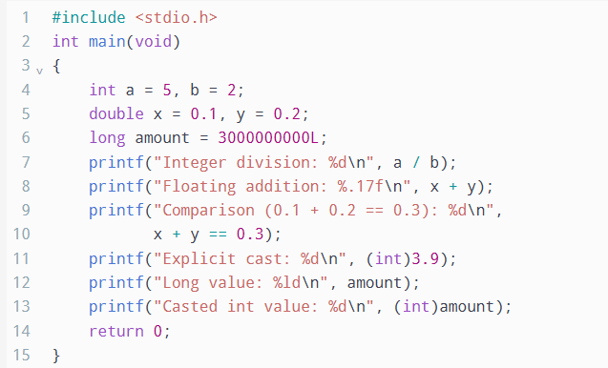

4. Output

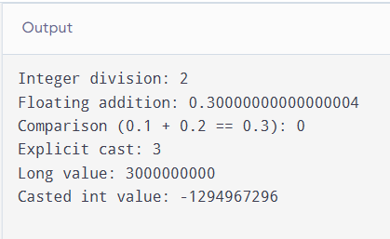

5. Explanation of Unexpected Results
1. Integer division
5 / 2 produces 2, not 2.5, because both operands are integers and the fractional part is discarded.
2. Floating-point addition
0.1 + 0.2 may produce 0.30000000000000004 because decimal fractions cannot always be represented exactly in binary floating-point format.
3. Floating-point comparison
The expression 0.1 + 0.2 == 0.3 produces 0 (false) on a typical IEEE 754 system because the two calculated values are not exactly equal.
4. Explicit casting
(int)3.9 produces 3 because conversion from floating point to integer discards the fractional part; it does not round to the nearest integer.
5. Large integer conversion
Casting a long value that exceeds the range of int can change its value. Therefore, a large bill total should not be converted to int without checking its range.

6. Type Conversion in Billing Calculations
- Implicit conversion: Smaller integer types may be promoted to int during arithmetic. When different arithmetic types are combined, the usual arithmetic conversions determine the resulting type.
- Explicit casting: (long)(units - 200) * RATE3_PAISE converts the first operand to long before multiplication, helping prevent overflow in the multiplication when the result fits in long.
- Integer division: bill_paise / 100 gives whole rupees, while bill_paise % 100 gives the remaining paise.
- Rounding: If a fractional charge is calculated, convert it to paise using a consistent rule, such as rounding to the nearest paise. For non-negative amounts, this can be expressed as floor(amount_in_rupees * 100 + 0.5), assuming the intermediate value is sufficiently accurate.

7. Alternative Concept and Complexity Analysis
If all bills were calculated using float, the total could be calculated as a floating-point sum and rounded to two decimal places at the end. However, floating-point representation errors may accumulate, so rounding only once does not guarantee an exact monetary total.
Feature | Integer paise | Float rupees
Typical size | 8 bytes using long long | 4 bytes
Addition time | O(1) | O(1)
Total time for n bills | O(n) | O(n)
Precision | Exact whole paise within range | Approximate
Rounding error | None during integer addition | May accumulate
For (n) bills, integer addition takes O(n) time and O(1) extra space when maintaining a running total. Floating-point errors depend on the values and order of addition; they do not necessarily grow at a fixed rate.

8. Result
Type conversion, integer division, explicit casting, and floating-point precision were demonstrated using C expressions. Integer paise is recommended for electricity billing because it avoids fractional-paise errors during addition, provided the total remains within the integer type's range.

